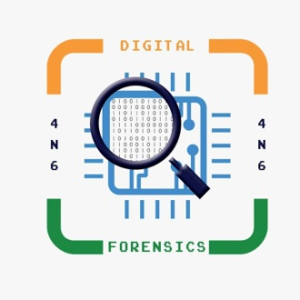**FORENSIC BASICS OF MACHINE 2 BRAIN INTERFACE**

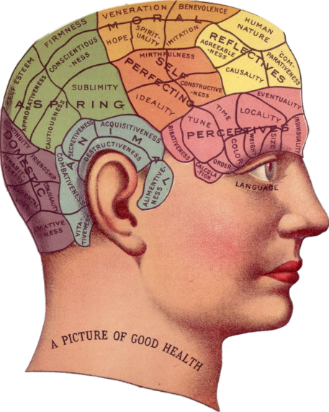**BRAIN MACHINE INTERFACE**

In human, brain is a very complex part of the body, where brain consist approx 100 billion neurons which plays an important role in their life. To measure or read the signals of the brain without machine is quite difficult. So to measure or read the activities of the complex brain through a device which is known as Brain Computer Interface (BCI). A brain-computer interface is a device that can translate neurological signals and transmit them to external software or hardware, which can then perform an action. It is a powerful tool for communication between machine and user. It is a communication system that can read a certain set of brain signal pattern through external device such as computer. It acquire the activity from the brain and nerves in electrical way.

For example: Some of the advanced prosthetics which is currently in development. Which takes signals from the brain and turn them into an algorithm that would make an artificial limb move. This development would allow a user to move a prosthetic limb by simply thinking about it.

In BCI (Brain Computer Interface) devices based on "Neuroprostheses technology which use electrodes to interface with the peripheral or central nervous system to restore lost sensory capabilities.

Restoration through electrical stimulation which inhibits or excites neural tissue or reading the electrical signals which is generated by the brain or nerves and then external device which is controlled by the use of BCI.

**EEG:** Firstly it stands for electroencephalogram, it is like a small metal disk which measure electrical signal of the brain and it also help to diagnose sleep disorders, coma and brain death etc.

**EMG:** Firstly it stands for Electromyography which helps to record the electrical activity of muscles through electric sensors and it helps to diagnose the abnormalities in order to identify neuromuscular diseases.

**TYPE OF BCI**

Brain Computer Interface can be classified into three type:

1. Non-Invasive
2. Semi-Invasive
3. Invasive

**BRAIN SIGNALS MEASUREMENT:**

Brain signals (Neuronal ) are measured by:

* Without surgery, over the head topical electric sensors are placed to measure electric sensors such as hat, patch or belt.
* Brain activities or signals reads by Electroencephalography (EEG) and muscle activities reads by Electromyography (EMG).
* Electrocorticography (ECoG) or intracranial electroencephalography; iEEG) : it is a process in hich electrodes are placed inside of the skull, above the surface of the brain.
* when electrodes penetrate the tissue of the brain then Intracortical recording occurs. This technique records neural activity from an assembly of single brain cells.

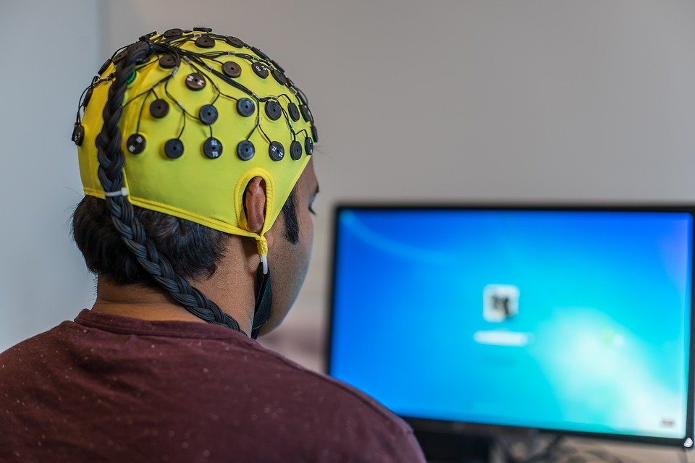

In the medical field also, BCI play an important role by the neuro prosthetics which can enhance the sense and behaviour of the body such as hearing ,vision, mood, cognition mobility and communication. Some specific examples such as:

* Cochlear Implants: This is a kind of hearing device which is based on electrical signals and then sent to the brain where it is interpreted as sound.
* Visual prostheses: This device is useful for those whose loss their vision and it is based on electrical signals, which stimulate the visual cortex where an electrode array has been placed. Ex Argus II.
* Brain stimulation, where some several variation including :
  + - Deep braining Stimulation (DBS): This device is used for monitored the excited stimulations of the brain and it is useful for treatment of parkinson's disease, obsessive compulsive disorder (OCD) and tremor symptoms.
    - Transcranial Direct Current stimulation (tDCS): This technique which helps to enhance cognition and modulate stress levels.
    - Transcranial Alternating Current Stimulation (tACS): This technique is useful for treatment for epilepsy, schizophrenia or cognitive impairment.
    - Repetitive Transcranial Magnetic stimulation (rTMS): This technique is useful for treatment for auditory hallucinations and depression.

**ROLE OF BCI IN FORENSIC**

BCI also play an important role in forensic field as we know that our brain which acquire a high volume of brain data, which contains sensitive information in form of memory , thought, and emotion, for example. Such information could be manipulated by authorities or criminals, in the event a BCI device is hacked. Some examples:

* Criminal Forensic Lie Detection: This technique is used as a tool in forensic investigation where the electrical signals of the brain electroencephalography (EEG) is measured which includes the person's behaviour, mood, emotions, fear in the form of signals.
* Computer user Authentication: The brain waves of the person, recorded in real time, can be used as a password to unlock the screen.
* Retrieving password from a User's Brain: Researchers figured out a way to pluck sensitive information from a person’s head, such as PIN numbers and bank information which includes login ID ,passwords and other relevant credentials.
* Reveals Individual Thoughts by Tracking Brain Signals: By measuring the brain signals at the precise time the images were displayed, researchers could glean clues about the player's thoughts and feelings about the images in the form of stimulation This suggests that the same setup could be used to extract much more sensitive information, including a person's religious beliefs, political leanings, medical conditions, and prejudices.

**CONCLUSION:**

Brain signals reflect the activities and controlling behavior of the brain or the influence of the received information (in form of signal) from other body parts either sensing or internal organs. Brain Computer Interfacing provides a channeling facility between brain and external equipment. BCI application growing in fields such as medical, organizational, transportation, games and entertainment, and security and authentication fields.

**REFERNCES:**

* https://www.sciencedirect.com/topics/neuroscience/brain-computer-interface
* https://medium.com/predict/a-brain-machine-interface-will-be-the-next-level-in-evolution-ce0f9f57417
* https://www.researchgate.net/publication/251859988_Brain_computer_interface_as_a_forensic_tool
* https://scipol.duke.edu/learn/science-library/brain-computer-interface-based-neuro-prosthetics.
* https://towardsdatascience.com/a-beginners-guide-to-brain-computer-interface-and-convolutional-neural-networks-9f35bd4af948

**ABOUT AUTHOR**

My name is Jyoti Singh from New Delhi. I am pursuing PG Diploma in Journalism and Mass Communication from IGNOU University. I have completed M.Sc Forensic Science from SHUATS, Allahabad (U.P). I have worked around various field of Forensic Science. I have certification in Forensic Ballistics, cyber security and internship experience in Forensic Serology from Forensic Science Laboratory, Chanakyapuri New Delhi and I have gained some experience in Crime

Scene Investigations while training under Delhi police and UP Police

crime branch.